Software Testing Assignment

Module 1(Fundamental)
- What is SDLC?
- SDLC stands for Software Development Life Cycle.

- SDLC is a structure imposed on the development of a software product that defines the process for planning, implementation, testing, documentation, deployment, and ongoing maintenance and support.

- SDLC phases
- Requirement gathering
- Analysis
- Design
- Implementation
- Testing
- Maintenance

- What is Software Testing?
- Software Testing is a process used to identify the correctness, Completeness, and quality of developed computer software.

- What is agile methodology?

- Agile methodology is a combination of iterative and incremental process models with focus on process adaptability and customer satisfaction by rapid delivery of working software product.
- Agile Methods break the product into small incremental builds.
- These builds are provided in iterations.
- Each iteration typically lasts from about one to three weeks.
- Every iteration involves cross functional teams working simultaneously on various areas like planning, requirements analysis, design, coding, unit testing, and acceptance testing.

- What is SRS?
- A software requirements specification (SRS) is a complete description of the behaviour of the system to be developed.
- It includes a set of use cases that describe all of the interactions that the users will have with the software.

- What is oops?
- Object-Oriented Programming (OOP) is a programming paradigm that organizes software design around objects, which are instances of classes that encapsulate both data and behavior.

- Write Basic Concepts of oops?

- Object
- Class
- Encapsulation
- Inheritance
- Polymorphism
- Abstraction

- What is object?
- Object is instance of class with state and behaviour.
Every object is defined by three core characteristics:
- State (Attributes/Data): These are the properties or variables that store information about the object. For a Car object, this might be color: Red or speed: 60mph.
- Behaviour (Methods/Functions): These are the actions the object can perform. A Car object might have methods like start(), accelerate(), or brake().
- Identity: This is a unique handle or memory address that distinguishes one object

- What is class ?

- Class is structure in which we can help member function and member variable.

- What is encapsulation?
- Wrapping data in to single Unit.
- Encapsulation is the process of bundling data (attributes) and the methods that operate on that data into a single unit.

- What is inheritance?
- Inheritance means that one class inherits the characteristics of another class.
- This is also called a “is a” relationship.

- What is polymorphism?
- Polymorphism means “having many forms”.
- Same Function name but having different functionalities.

- Draw Usecase on online bill payment system (Paytm)

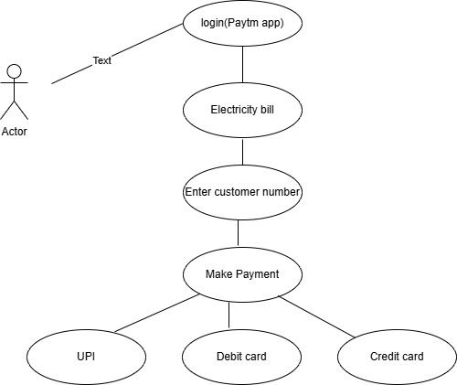

- Draw Usecase on banking system for customers

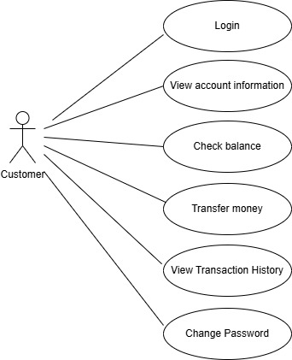

- Draw Usecase on Broadcasting System.

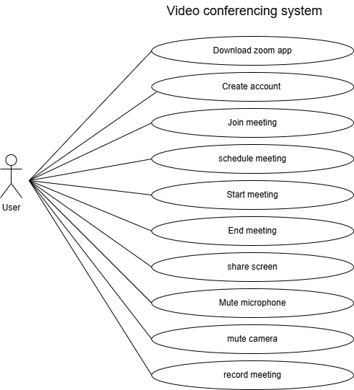

- Write SDLC phases with basic introduction.

- Planning/Requirement Analysis: Define what the software should achieve and gather detailed specifications from all customer/client.
- Design: Create a technical blueprint and architectural plan for how the software will function.
- Development: Write the actual code and build the software product based on the design specifications.
- Testing: Verify that the implemented software works correctly, meets requirements, and is free of bugs.
- Deployment: Release the finished software into the live production environment for end-users to access.
- Maintenance: Provide ongoing support, fix issues, and apply updates or delete.

- Explain phases of the Waterfall model?

- Requirement gathering and Analysis: The first step is to understand the customer’s needs and Document them accurately.
- Design: The requirement specifications from first phase are studied in this phase and the system design is prepared. This system design helps in specifying hardware and system requirements and helps in defining the overall system architecture.
- Implementation: Write clean code that meets the design specification.
- Testing: Test thoroughly to ensure the software works as intended.
- Maintenance: Provide ongoing support, fix issues, and apply updates or delete.

- Write phases of spiral model.

There are four main phases of spiral model:

- Planning (or Objectives Determination): In this phase, the objectives for the specific iteration of the product are defined. This includes gathering detailed requirements, identifying alternative solutions, and establishing the constraints of the project (e.g., budget, schedule, resources) through ongoing communication with the customer.
- Risk Analysis: This critical phase involves identifying potential technical and management risks associated with the defined objectives and alternative solutions. Strategies to mitigate these risks are planned and evaluated, often by creating a prototype to resolve uncertainties and gather initial user feedback.
- Engineering (or Development and Testing): The actual development and testing of the software take place in this phase. The features and functionalities identified for the current iteration are designed, coded, and verified through thorough testing (unit, integration, etc.). A working version or build of the software is produced at the end of this phase.
- Evaluation (or Customer Review and Planning for the Next Phase): The developed product is evaluated by the customer or stakeholders, who provide feedback. Based on this feedback and a review of the progress and remaining risks, planning for the next phase or iteration of the spiral begins, with a decision on whether to continue the project or terminate it if risks are too great.

- Write agile manifesto principles.

- There are 4 Core Values:

- Individuals and interactions over processes and tools.
- Working software over comprehensive documentation.
- Customer collaboration over contract negotiation.
- Responding to change over following a plan.

- There are 12 guiding principles
emphasizing customer satisfaction through frequent, valuable delivery, embracing changing requirements, fostering daily developer-business collaboration, building around motivated individuals, preferring face-to-face talk, and promoting sustainable development, technical excellence, simplicity, self-organizing teams, and continuous reflection for improvement.

- Explain working methodology of agile model and also write pros and cons.

- The Agile model is an iterative, collaborative approach to project management, especially software development, focusing on flexibility, customer feedback, and delivering working increments frequently through short cycles (sprints).
- Its core methodology involves continuous planning, development, testing, and review in small batches, allowing teams to adapt to changing requirements quickly.
- Agile SDLC model is a combination of iterative and incremental process models with focus on process adaptability and customer satisfaction by rapid delivery of working software product.
- Agile Methods break the product into small incremental builds. These builds are provided in iterations.
- Each iteration typically lasts from about one to three weeks.
- Every iteration involves cross functional teams working simultaneously on various areas like planning, requirements analysis, design, coding, unit testing, and acceptance testing.
- At the end of the iteration a working product is displayed to the customer and important stakeholders.

PROS:
  - Enhanced flexibility
  - Faster delivery
  - Higher customer satisfaction
  - Better team communication

CONS:
  - less upfront documentation
  - difficulty predicting final timelines/costs
  - need for high stakeholder involvement.

- Draw usecase on OTT Platform.

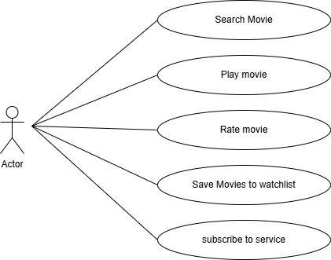

- Draw usecase on E-commerce application

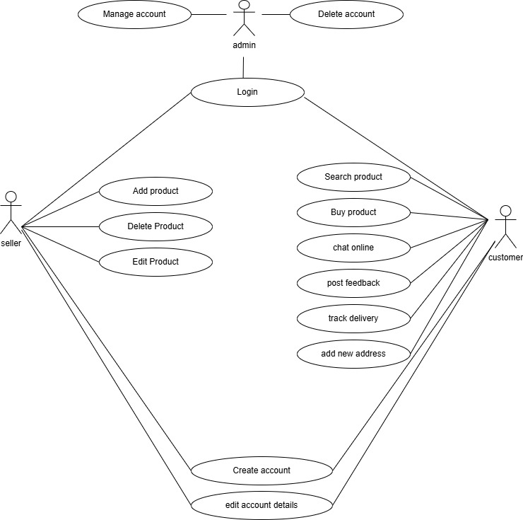

- Draw usecase on Online shopping product using payment gateway.

